

**TRIBHUVAN UNIVERSITY**

**FACULTY OF HUMANITIES AND SOCIAL SCIENCE**

**A Project Report**

**On**

**"Vastra: A Clothing Website"**

**Submitted to**

**Department of Computer Application**

**National College of Computer Studies**

In partial fulfillment of the requirements for Bachelor Degree in Computer Application

**Submitted By:**

**Binay Manandhar**

**Samman Phuyal**

**Under the Supervision of**

**Radha Krishna Gajurel**

# ABSTRACT

Ecommerce, also known as electronic commerce or internet commerce, refers to the buying and selling of goods or services using the internet, and the transfer of money and data to execute these transactions. Ecommerce is Often used to refer to the sale of physical products online, but it can also describe any kind of commercial transaction that is facilitated through the internet.

This website is a business to consumer model which means we sell goods and services to an individual consumer (e.g. You buy a pair of shoes from an online retailer). Since it is a small business and we are just starting the products are in low quantity and the delivery service is not yet introduced. The website offers different shopping categories like shirts, pants etc. Any product can be bought within the offered price range. Users can easily place a place in the cart and the cart design very simple and intuitive.

# ACKNOWLEDGEMENT

We would like to thank our supervisor Mr. Radha Krishna Gajurel for his valuable guidance who gave us great encouragement for this work and helpful suggestions. We would also like to thank our Vice Principle sir, Mr. Santosh Maskey who monitored, guided and motivated us throughout all the phases of this project. We appreciate the support from all the supervisors and friends to help make this project successfully.

Binay Manandhar

Samman Phuyal

# Table of Content

ABSTRACT i

ACKNOWLEDGEMENT ii

Table of Content iii

Table of Figures iv

Chapter 1: Introduction 1

1.1 Introduction 1

1.2 Problem Statement 1

1.3 Objective 1

1.4 Scope and Limitation 1

1.5 Report Organization 1

1.5.1 Introduction 1

1.5.2 Background study and literature review 1

1.5.3 System analysis and design 2

1.5.4 Implementation and testing 2

1.5.5 Conclusion and future recommendation 2

Chapter 2: Background Study 3

2.1 Background Study 3

2.1.1 Study of existing system 3

Chapter 3: System Analysis and Design 4

3.1 System Analysis 4

3.2 Requirement Identifications 4

3.2.1 Functional Requirements 4

3.2.2 Non-Functional Requirements 5

3.3 Feasibility Study 5

3.3.1 Technical Feasibility 5

3.3.2 Operational Feasibility 5

3.3.3 Economic Feasibility 5

3.4 High Level Design 6

3.4.1 Flowchart 6

3.4.2 Usecase 7

3.4.3 Entity Relationship 8

3.4.4 Database Schema Diagram 9

Chapter 4: Implementation and Testing 10

4.1 Implementation 10

4.1.1 Tools Used 10

Chapter 5: Conclusion and Future Recommendations 11

References 12

# Table of Figures

Figure 3.1 Agile Model 4

Figure 3.2 Flowchart Diagram 6

Figure 3.3 Usecase Diagram 7

Figure 3.4 E-R Diagram 8

Figure 3.5 Database Schema 9

# Introduction

## Introduction

**Online shopping** is a form of electronic commerce which allows consumers to directly buy goods or services from a seller over the Internet using a web browser or a mobile app. Consumers find a product of interest by visiting the website of the retailer directly or by searching among alternative vendors using a shopping search engine, which displays the same product's availability and pricing at different e-retailers. [1] This proposal report outlines the design and development of a Clothing Website that will streamline the booking process for Futsal players.

## Problem Statement

Traditionally we see that the Shopping sites contain a lot of products and it is very difficult for the users to choose from. They have to waste a lot of time choosing products and end up buying nothing. Product quality and quantity is poor and irrelevant product are kept everywhere.

## Objective

Our website focuses on providing quality services for the customer. The main aim of the shopping website is listed below:

* To develop an E-Commerce website which would be simple to use.
* To develop a website so that user would not have to spend a lot of time choosing what is right for them.
* To make buying and paying for the product is made much simpler.

## Scope and Limitation

The domain of this project is to allow user to buy clothes from any place at any time as their choice and enjoy without complication of needing to go to a shop physically.

The main drawback of this project is that user will not be able to touch and feel the merchandise they will buy through online shopping.

## **Report Organization**

### Introduction

Chapter one introduces the concept of this project. It describes the problems that has been existing and how its objective can tackle it. It also presents the scope and limitations of the project.

### Background study and literature review

This chapter focuses on the basic ideology of how this project will be build. It traces out the study of different platforms and their workings.

### System analysis and design

This chapter describes the requirements gathering, feasibility study, and designing of the project. It includes diagrams, functionality analysis, requirement gathering technique and process model.

### Implementation and testing

This chapter is designed to give information about how the project has been implemented, what kind of software and tools has been used and the type of testing that the project has gone through.

### Conclusion and future recommendation

This chapter includes the possible outcome of this project, conclusion and future recommendations

# Background Study

## Background Study

It is the study of history of booking and recording of a certain system. The existing system has been studies as the background study for this project.

### Study of existing system

Many shopping websites were visited for the purpose of system study. These websites include ktmcty.com, sastodeals.com, ufonepal.com, etc. These websites provide immense features which can be both easy to use and learn. These websites allow user to search for their choice of clothing in real time.

# System Analysis and Design

Considering the fact that this project involves design and implementation of a software system regardless that it is web-based, it will be important to mention and consider some models used in software development and deployment. After reading though all the models. The waterfall model fits the development of this website. The main aim of using this approach is, we can focus on each part of the model during development and come back to it if need be. The project can easily be broken down into different parts based on this model.

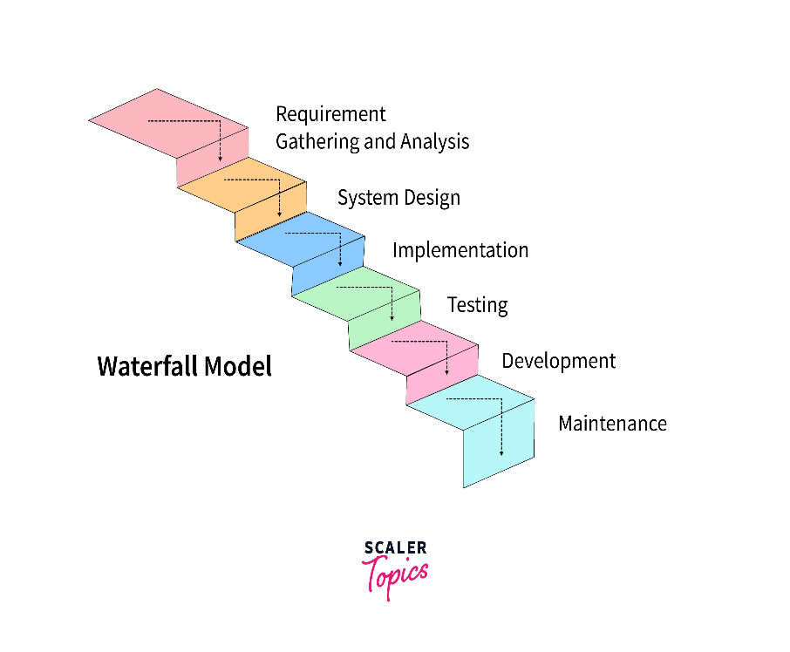

Figure 3.1 Waterfall Model

## Requirement Identifications

The process of obtaining important specifications that will be utilized to create a system is known as requirement identification. [2] There are several ways to obtain requirements, such as reviewing the existing system, conducting interviews, using questionnaires, etc.

### Functional Requirements

The requirement that has been used in the project as the functional requirements generally includes the function such as inputs, the processing and the final output. The functional requirements in the project are mentioned below.

l. User Module

• User can register and login the system.

• User can get cart detail after updating each product.

• User can link their bank account to complete the buy process.

• User can logout from the system after completion of transaction.

2. Admin Module

• Admin can login the System.

• Admin can add and delete products.

• Admin can see the registered users.

• Admin has privilege to delete the user.

• Admin can logout from the system.

### Non-Functional Requirements

The non-functional requirement specifies how the system works. The non-functional requirements included in the project are:

• System uses different database for storing the attribute for each entity.

• User can see the transaction detail after performing transaction.

## Feasibility Study

The purpose of a feasibility study is to determine how effectively a system will operate given constraints. It investigates how simple it is to construct a system given certain constraints. Operational feasibility, economic feasibility, and technical feasibility are some of the constraints.[3]

### Technical Feasibility

This system meets the technical feasibility as it will be using existing technologies like HTML, CSS, JavaScript, PHP and MYSQL as well as simple hardware specifications.

### Operational Feasibility

Since the system promises to provide easier and understandable user interface as well as responsiveness when used in another device. Thus, the proposed system will be operationally feasible.

### Economic Feasibility

Vastra will be economically feasible as it can attract a large user base, generate revenue, and have minimal development and maintenance costs.

## High Level Design

### Flowchart

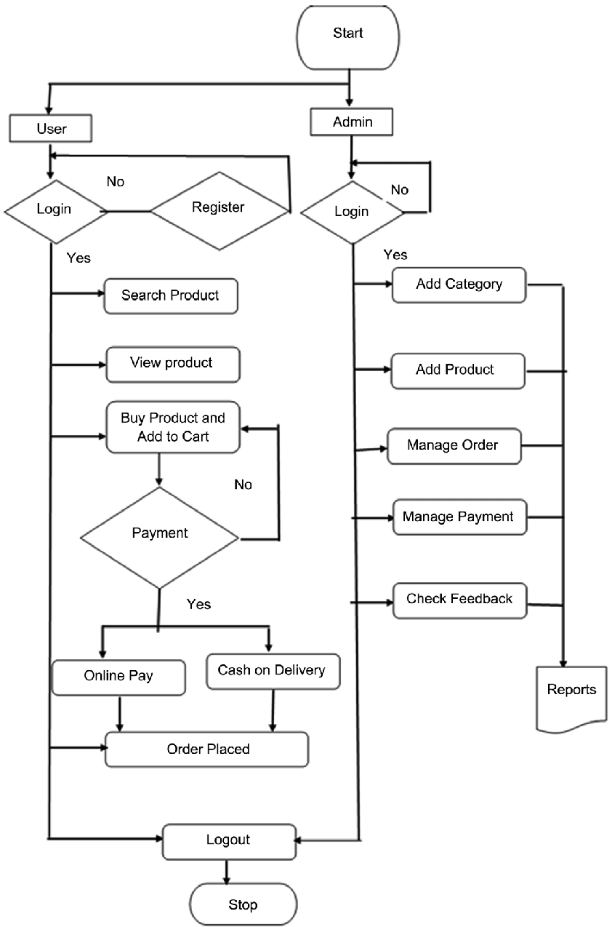

Figure 3.2 Flowchart Diagram

### Usecase

Figure 3.3 Usecase Diagram

### Entity Relationship

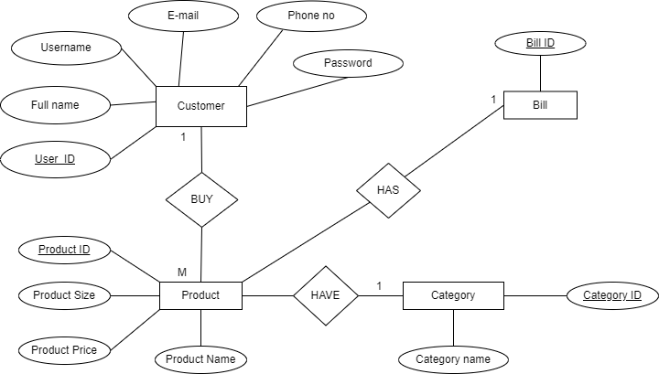

Figure 3.4 E-R Diagram

### Database Schema Diagram

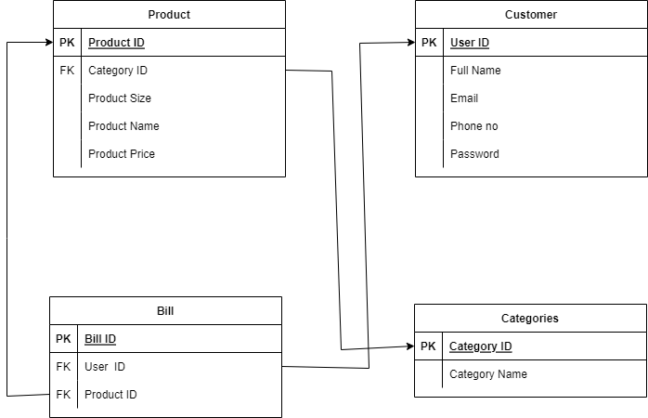

Figure 3.5 Database Schema

# Implementation and Testing

## Implementation

### Tools Used

**Frontend**

* HTML
* CSS
* JavaScript
* AJAX

**Backend**

* PHP

**Database**

* SQL

**Server**

* Apache

# Conclusion and Future Recommendations

## Lesson learnt/ outcome

The project will allow users to buy clothes of their liking at any time they want. It provides multiple

categories providing the feeling of novelty.

## **Conclusion**

This project is expected to deliver a high performance website with attractive and easy to use

UI. This project will meet all of its objectives as well as address all the shortcomings that has

been observed in most of the video streaming platform.

## Future Recommendations

# References

|  |  |
| --- | --- |
| [1] | "The Alibaba phenomenon". The Economics. March 23, 2013. ". |
| [2] | "Requirement Analysis Techniques," [Online]. Available: https://www.visual-paradigm.com/guide/requirements-gathering/requirement-analysis-techniques/. |
| [3] | S. Khadka, "FlickSpree," 2018. |